ADS Reminder Installation Guide

# Aim Of The Document

This document aims to the following.

1. To explain requirement of ADS Reminder.
2. How to install ADS Reminder with all dependencies on the PC.
3. First run of ADS Reminder.

# Requirements

1. NET Framework 4.7.2 – If you do not have it will be installed with setup.
2. SQL Server Local DB Express – If you do not have, it will be installed with setup.

# Installation Process

1. Download installation file from the following link.

<https://drive.google.com/file/d/1FJ2vAUp8N7XCeSgU-HIAz5yH2fwMo9Ex/view?usp=sharing>

1. Run the downloaded setup as admin.

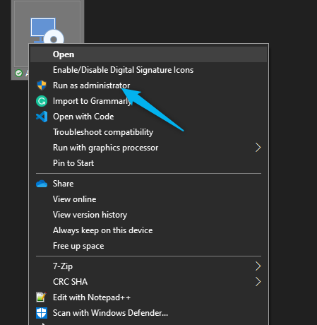

1. Accept license conditions and click “Install”.

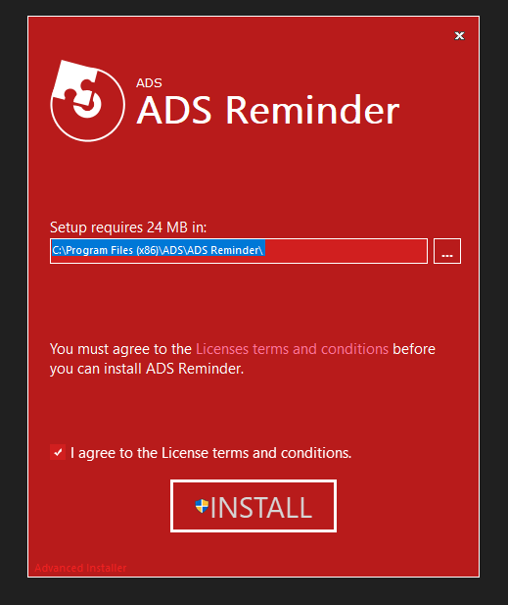

1. After installation completed, a shortcut is shown on your desktop.

After you run the app, you can login with test user to do quick start, you can create your own account on register section.

For test user type:

**Username: test, Password :test**